PROJECT DOCUMENTATION
AI BuddyStudy API
An AI-powered study companion delivered as an API
Submitted by
Arisya Fathima Y

1. Introduction
AI BuddyStudy API is a project that provides AI-driven study assistance through a set of API endpoints. It is designed to act as a “study buddy” for students, helping them understand topics, revise faster, and test their knowledge. The backend is built with Node.js and Express, the study history is stored in MongoDB Atlas, and the API is tested with Postman inside VS Code. Because it is built as an API, it can be connected to any website, mobile app or chatbot.

2. Objectives
- Make studying easier – give students quick, clear explanations of any topic.
- Save time – generate summaries, notes and practice questions automatically.
- Be reusable – expose all functions through a simple API that other apps can use.
- Store study history – save every request and answer in a cloud database.
- Encourage self-learning – let students practise and check their understanding anytime.

3. Features of the Project
The main features of AI BuddyStudy API are listed below.
- AI Doubt Solving – students ask a question and receive a simple, step-by-step answer.
- Topic Explanation – explains a concept in easy language with a short example.
- Smart Summaries – converts long text or notes into short, revision-ready summaries.
- Quiz Generation – creates multiple-choice questions with answers from any topic.
- Study History – every question and answer is saved in MongoDB Atlas and can be viewed later.
- REST API Access – simple HTTP requests with JSON responses, easy to integrate.
- Cloud Database – MongoDB Atlas keeps the data safe and accessible from anywhere.
- Error Handling – clear messages and status codes when a request is invalid.
- Easy Integration – works with web apps, mobile apps and other tools.

4. Tools and Technologies Used
Component | Technology
Code Editor | Visual Studio Code (VS Code)
Runtime / Language | Node.js (JavaScript)
Web Framework | Express.js
Database | MongoDB Atlas (cloud) with Mongoose
API Testing | Postman extension inside VS Code
AI Model | Claude API (Anthropic SDK)
Other Packages | dotenv, cors, nodemon

4.1 How each tool is used
- VS Code – used to write, run and debug the whole project in one place.
- Node.js – runs the JavaScript backend server outside the browser.
- Express.js – creates the routes (endpoints) and handles requests and responses.
- MongoDB Atlas – cloud database that stores each request and the AI answer as a document.
- Postman in VS Code – used to send test requests to the API and view the responses without leaving the editor.

5. API Endpoints
Endpoint | Method | Purpose
/api/explain | POST | Explain a topic in simple words
/api/summary | POST | Summarise the given text
/api/quiz | POST | Generate practice questions
/api/history | GET | View the latest saved study records

6. Database Design
The project uses one collection, studylogs, inside the buddystudy database on MongoDB Atlas.
Field | Type | Description
_id | ObjectId | Unique ID created automatically
type | String | explain, summary or quiz
input | String | The topic or text sent by the student
output | String | The answer returned by the AI
createdAt | Date | Time when the record was saved

7. Code Screenshots
The screenshots below show the main parts of the source code in VS Code.
Figure 1: Project folder structure
The project is organised into config, models, routes and services folders.
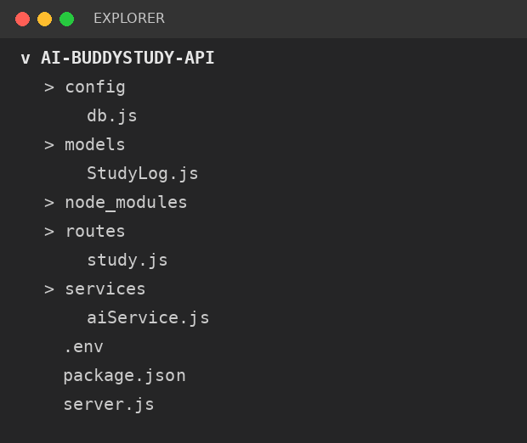
Figure 2: Main server file (server.js)
Starts the Express server, connects to MongoDB Atlas and loads the routes.
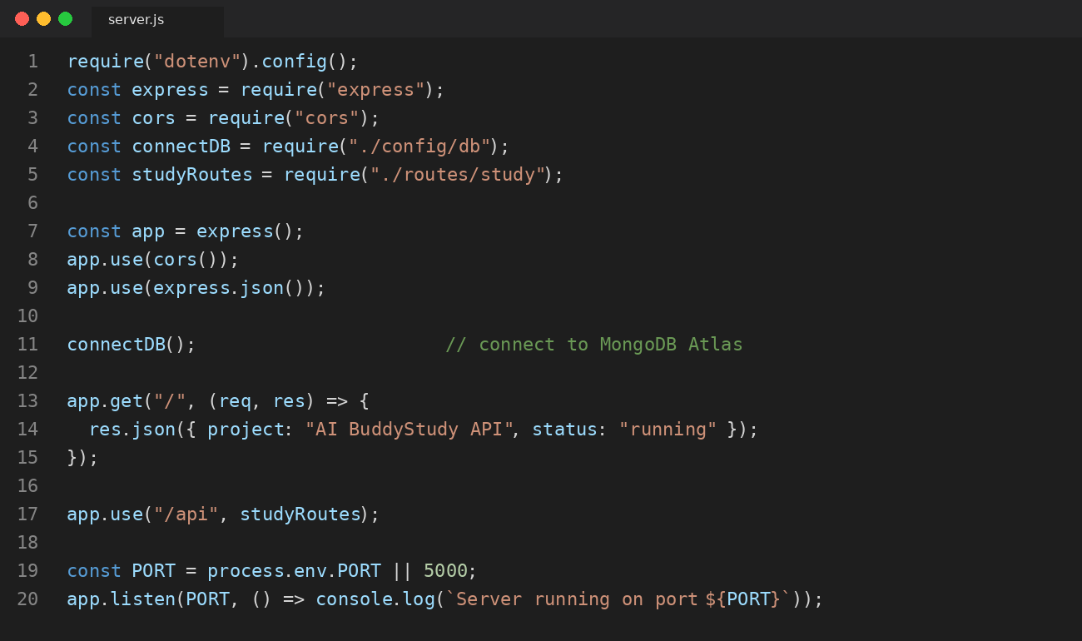
Figure 3: Database connection (config/db.js)
Connects the project to MongoDB Atlas using the connection string stored in .env.
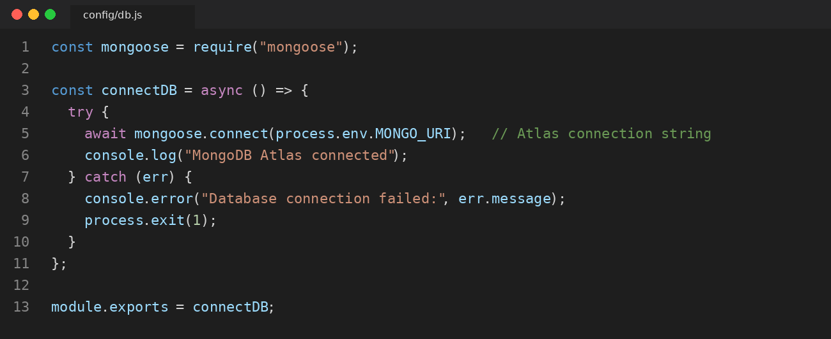
Figure 4: Database model (models/StudyLog.js)
Defines the structure of the records saved in MongoDB Atlas.
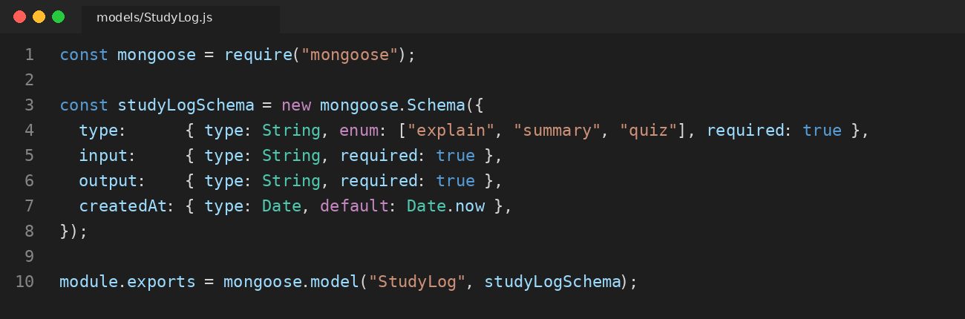
Figure 5: AI integration code (services/aiService.js)
Sends the student's request to the AI model and returns the answer.
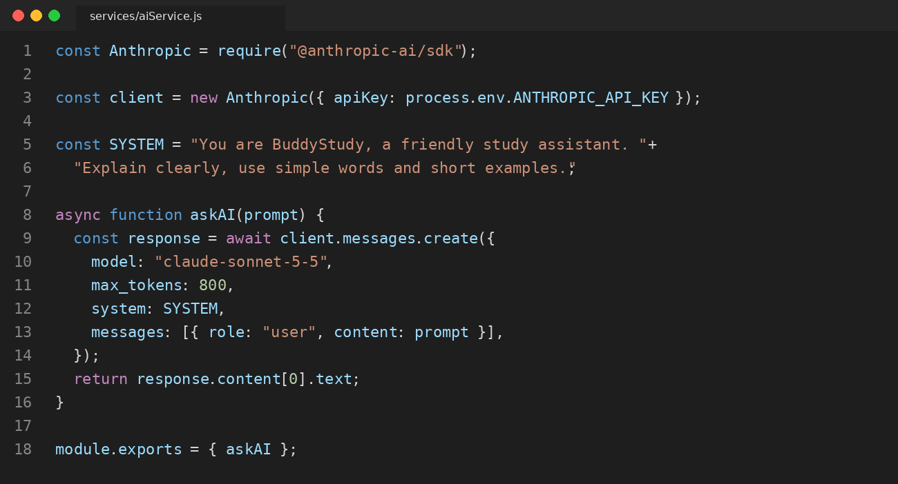
Figure 6: API routes (routes/study.js)
Defines the explain, summary, quiz and history endpoints with validation and saving to the database.
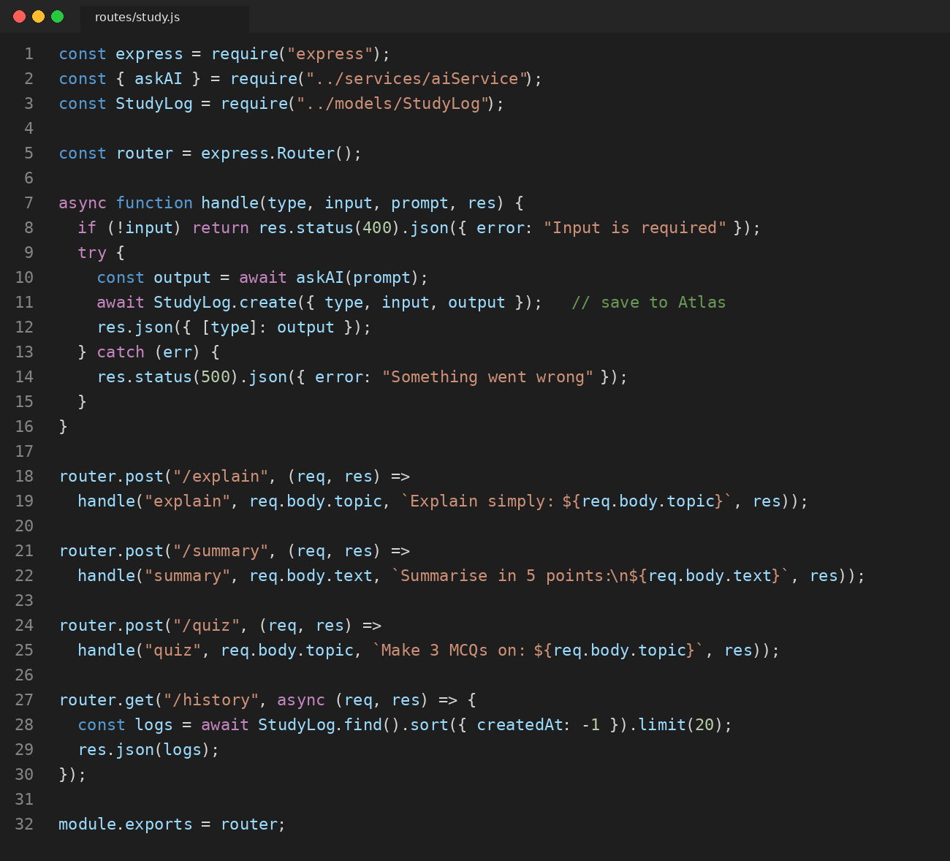

8. Output Screenshots
Sample outputs from running the project, tested with Postman in VS Code.
Figure 7: Server running in the VS Code terminal
The server starts on port 5000 and connects to MongoDB Atlas.
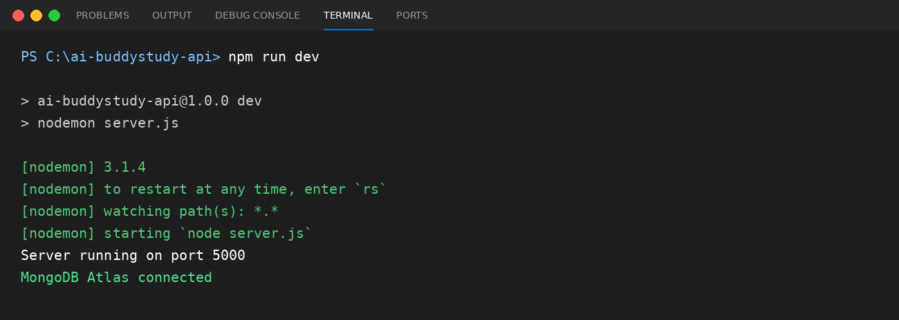
Figure 8: Explain API tested in Postman (VS Code)
A POST request to /api/explain returns a simple explanation with status 200 OK.
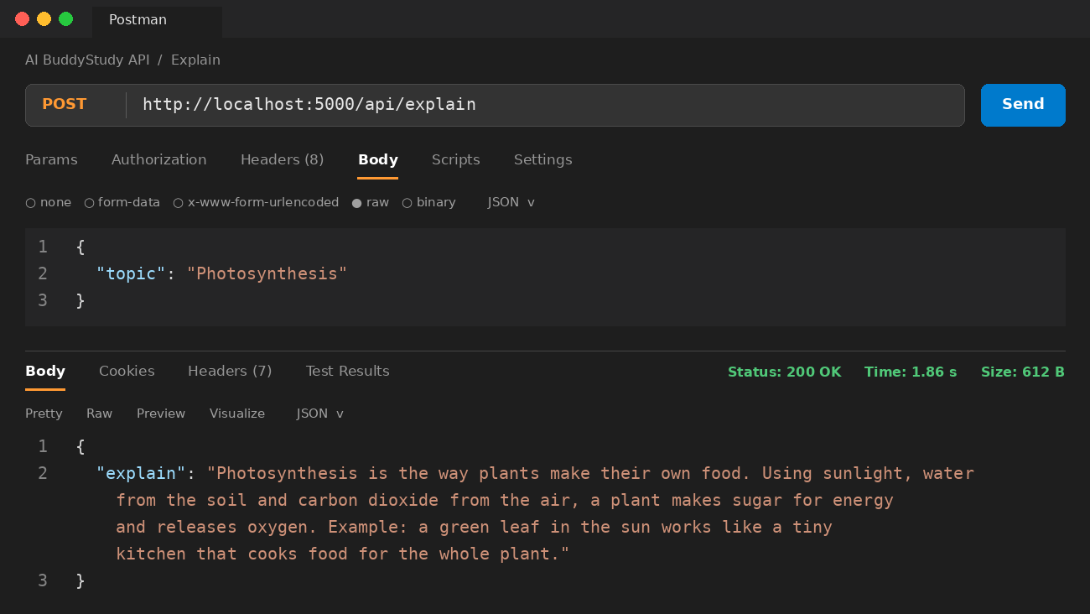
Figure 9: Quiz API tested in Postman (VS Code)
A POST request to /api/quiz returns multiple-choice questions with answers.
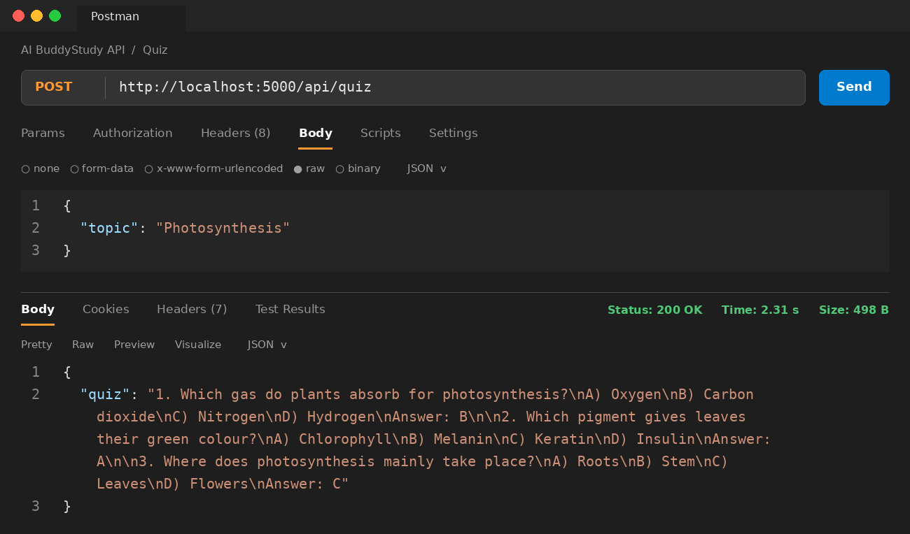
Figure 10: Saved records in MongoDB Atlas
Each request and answer is stored in the studylogs collection.
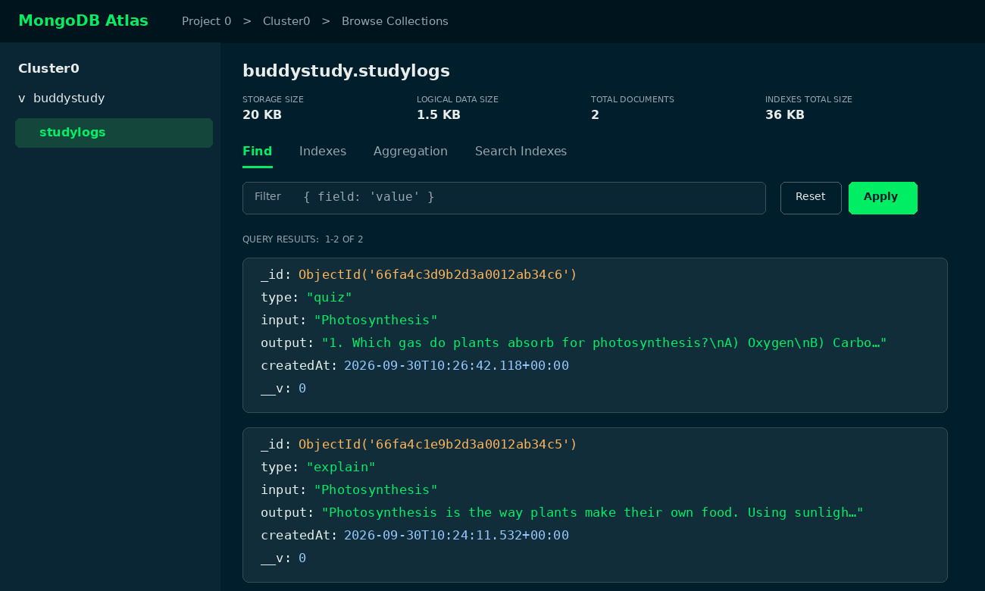

9. Conclusion
AI BuddyStudy API shows how artificial intelligence can support students in their daily learning. Built with Node.js, Express and MongoDB Atlas, and tested with Postman in VS Code, it offers doubt solving, explanations, summaries and quizzes through a simple API while keeping a history of all study activity. In the future it can be extended with user accounts, progress tracking, multi-language support and voice input.

